Chapter 3, Solution 92
Using Fig. 3.28, design a problem to help other students better understand transistors. Make sure you use reasonable numbers!
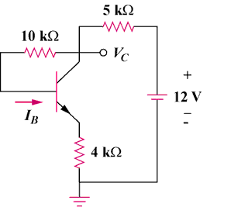
R₁
R₂
+
V₁
–
R₃

Figure 3.128
For Prob. 3.92.

Solution

Although there are many ways to work this problem, this is an example based on the same kind of problem asked in the third edition.

Problem
Find I_{B} and V_{C} for the circuit in Fig. 3.128. Let β = 100, V_{BE} = 0.7V.



Solution

+
V₀
–

4 kΩ
-

+

12V

+
V_{CE}
–

+
V_{BE}
–

I_{B}

I_{E}

10 kΩ

5 kΩ

V_{C}

I_{C}

I₁

I₁ = I_{B} + I_{C} = (1 + β)I_{B} and I_{E} = I_{B} + I_{C} = I₁

Applying KVL around the outer loop,

4kI_{E} + V_{BE} + 10kI_{B} + 5kI₁ = 12

12 – 0.7 = 5k(1 + β)I_{B} + 10kI_{B} + 4k(1 + β)I_{B} = 919kI_{B}

I_{B} = 11.3/919k = 12.296 μA

Also, 12 = 5kI₁ + V_{C} which leads to V_{C} = 12 – 5k(101)I_{B} = 5.791 volts

